Navam Tailoring and Boutique
Sreeja, Bindhu, Preethi and Lisy came to in front of the society with sewing machines. They decided to start stitching as a business when they came to know that the kudumbashree will provide loan for tailoring business. Thus the Navam tailoring and boutique had born on 2014.
Navam started by taking a loan of rupees 2 lakhs. First they purchased dress materials from Kollam. And then from Bengaluru and Ernakulam. Dress materials costs ranges from 120 to 1500 rupees.
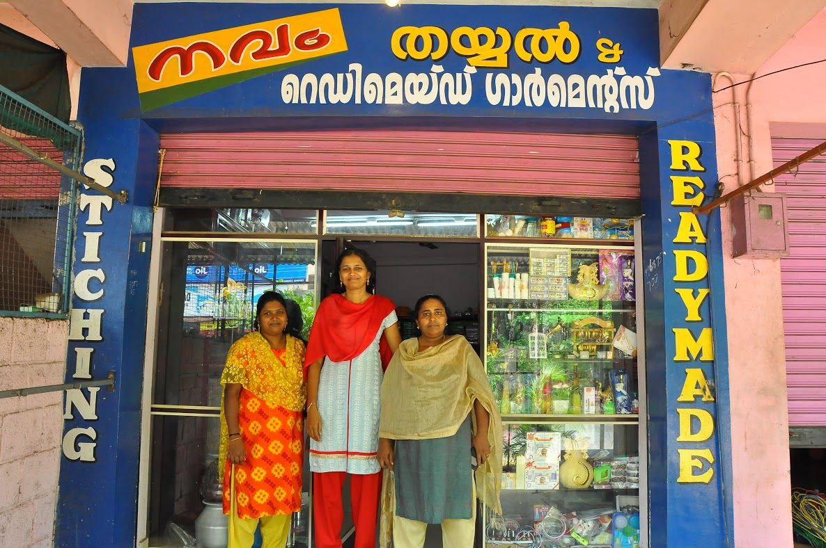
They works are done as per demand. The accounts and audits are properly managed. The unit is having 17 electrically operated tailoring machines. And they provide employment to 16 women in their village. Now they stitch school uniforms, as a part of plastic free campaign, they were involved in cloth bag. And also they took bulk orders from various companies.
The South African team and Sikkim team came to study the works of Kerala Kudumbashree had visited Navam’s projects. School youth festival dresses for children, various kinds of churidar, nighties, laches so on were available here. The unit is updated in choosing the designs and customised tailoring is also done. Each member earns up to 7000 rupee in a month.

